Factor Analysis

Notes
Output Created |  | 28-JUN-2021 14:03:45
Comments
Input | Active Dataset | DataSet54
Input | Filter | <none>
Input | Weight | <none>
Input | Split File | <none>
Input | N of Rows in Working Data File | 259
Missing Value Handling | Definition of Missing | MISSING=EXCLUDE: User-defined missing values are treated as missing.
Missing Value Handling | Cases Used | LISTWISE: Statistics are based on cases with no missing values for any variable used.
Syntax |  | FACTOR  /VARIABLES ZGrocery ZTransit ZResidential  /MISSING LISTWISE  /ANALYSIS ZGrocery ZTransit ZResidential  /PRINT UNIVARIATE INITIAL CORRELATION EXTRACTION ROTATION  /FORMAT SORT  /PLOT EIGEN  /CRITERIA FACTORS(3) ITERATE(25)  /EXTRACTION PC  /CRITERIA ITERATE(25)  /ROTATION VARIMAX  /METHOD=COVARIANCE.
Resources | Processor Time | 00:00:00.22
Resources | Elapsed Time | 00:00:00.26
Resources | Maximum Memory Required | 1984 (1.938K) bytes

[DataSet54]

Descriptive Statistics
 | Mean | Std. Deviation | Analysis N
ZGrocery | 2.69591070 | 1.000000438 | 86
ZTransit | 2.88486953 | 1.000000038 | 86
ZResidential | 1.95088860 | .999999373 | 86

Correlation Matrix
 |  | ZGrocery | ZTransit | ZResidential
Correlation | ZGrocery | 1.000 | .448 | -.166
Correlation | ZTransit | .448 | 1.000 | -.874
Correlation | ZResidential | -.166 | -.874 | 1.000

Communalities
 | Raw |  | Rescaled
 | Initial | Extraction | Initial | Extraction
ZGrocery | 1.000 | 1.000 | 1.000 | 1.000
ZTransit | 1.000 | 1.000 | 1.000 | 1.000
ZResidential | 1.000 | 1.000 | 1.000 | 1.000

Extraction Method: Principal Component Analysis.

Total Variance Explained
 | Component | Initial Eigenvaluesª |  |  | Extraction Sums of Squared Loadings
 | Component | Total | % of Variance | Cumulative % | Total | % of Variance
Raw | 1 | 2.056 | 68.531 | 68.531 | 2.056 | 68.531
Raw | 2 | .867 | 28.901 | 97.432 | .867 | 28.901
Raw | 3 | .077 | 2.568 | 100.000 | .077 | 2.568
Rescaled | 1 | 2.056 | 68.531 | 68.531 | 2.056 | 68.531
Rescaled | 2 | .867 | 28.901 | 97.432 | .867 | 28.901
Rescaled | 3 | .077 | 2.568 | 100.000 | .077 | 2.568

Total Variance Explained
 | Component | Extraction Sums of Squared Loadingsª | Rotation Sums of Squared Loadings
 | Component | Cumulative % | Total | % of Variance | Cumulative %
Raw | 1 | 68.531 | 1.802 | 60.078 | 60.078
Raw | 2 | 97.432 | 1.082 | 36.072 | 96.149
Raw | 3 | 100.000 | .116 | 3.851 | 100.000
Rescaled | 1 | 68.531 | 1.802 | 60.078 | 60.078
Rescaled | 2 | 97.432 | 1.082 | 36.072 | 96.149
Rescaled | 3 | 100.000 | .116 | 3.851 | 100.000

Extraction Method: Principal Component Analysis.
a. When analyzing a covariance matrix, the initial eigenvalues are the same across the raw and rescaled solution.

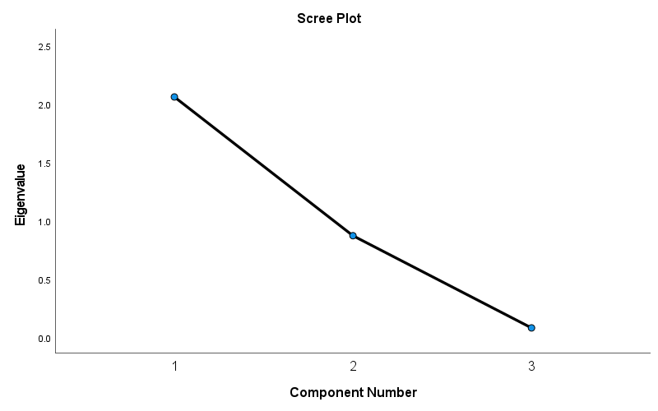

Component Matrixª
 | Raw |  |  | Rescaled
 | Component |  |  | Component
 | 1 | 2 | 3 | 1 | 2 | 3
ZTransit | .975 | -.095 | .202 | .975 | -.095 | .202
ZResidential | -.894 | .411 | .179 | -.894 | .411 | .179
ZGrocery | .554 | .830 | -.066 | .554 | .830 | -.066

Extraction Method: Principal Component Analysis.ª
a. 3 components extracted.

Rotated Component Matrixª
 | Raw |  |  | Rescaled
 | Component |  |  | Component
 | 1 | 2 | 3 | 1 | 2 | 3
ZResidential | -.996 | -.039 | .076 | -.996 | -.039 | .076
ZTransit | .890 | .317 | .327 | .890 | .317 | .327
ZGrocery | .132 | .990 | .051 | .132 | .990 | .051

Extraction Method: Principal Component Analysis.
Rotation Method: Varimax with Kaiser Normalization.ª
a. Rotation converged in 4 iterations.

Component Transformation Matrix
Component | 1 | 2 | 3
1 | .891 | .434 | .136
2 | -.443 | .895 | .049
3 | -.100 | -.104 | .989

Extraction Method: Principal Component Analysis.
Rotation Method: Varimax with Kaiser Normalization.

